**SQL Assignment 1**

**Query 1:- Write a query to get a Product list (id, name, unit price) where current products cost less than $20.**

select ProductID,ProductName,UnitPrice from products where UnitPrice < 20 and Discontinued=0;

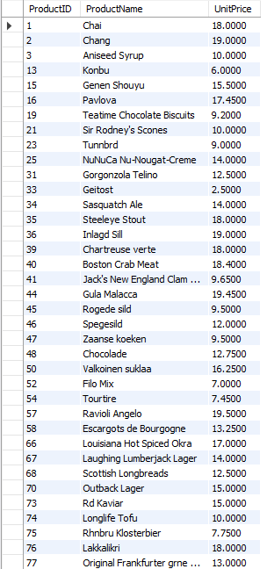

**Query 2:- Write a query to get Product list (id, name, unit price) where products cost between $15 and $25.**

select ProductID,ProductName,UnitPrice from products where UnitPrice between 15 and 25;

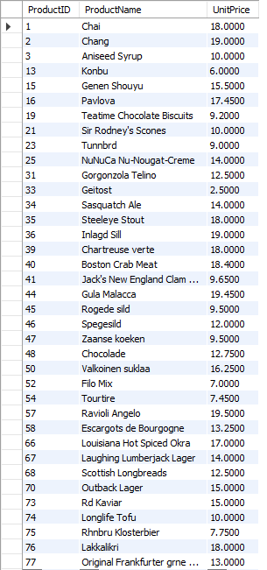

**Query 3: Write a query to get Product list (name, unit price) of above average price.**

select ProductName,UnitPrice from products where UnitPrice > (select avg(UnitPrice) from Products);

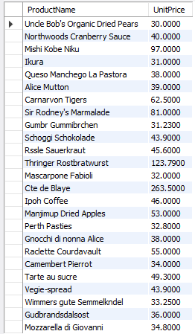

**Query 4: Write a query to get Product list (name, unit price) of ten most expensive products.**

select ProductName,UnitPrice from Products order by UnitPrice desc limit 10;

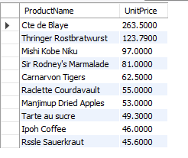

**Query 5:Write a query to count current and discontinued products.**

select count(ProductID),discontinued from products group by discontinued;

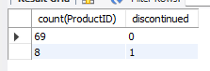

**Que 6: Write a query to get Product list (name, units on order , units in stock) of stock is less than the quantity on order.**

select ProductName,UnitsOnOrder,UnitsInStock from products where UnitsInStock < UnitsOnOrder;

